**Project Title: Analytics for Hospital Health-Care Data Project Design Phase-I** - **Solution Fit Template Team ID:** PNT2022TMID40633

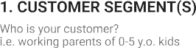

Hospital management and patients.

Not able to predict the patient LOS properly especially during the pandemic period

Effective hospital bed management using data mining technique

.

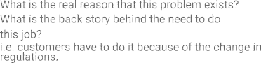

Regularly monitoring the database of patients and measures to avoid error

Insufficient analysis in data ,human error and poor scheduling.

Need the proper data analysis of allocation of beds and other needs of patients

|  |  |  |  |  |  |
| --- | --- | --- | --- | --- | --- |
|  | **3. TRIGGERS TR**  What triggers customers to act? i.e. seeing their neighbour installingsolar panels, reading about a more efﬁcient solution in the news | **10. YOUR SOLUTION SL** | 1. **CHANNELS of BEHAVIOUR**    1. **ONLINE** | **CH** |  |
| Prevailing emergency situations and Pandemic period situations and Pandemic period | Using **predictive analysis** powered by the AI which is used in analytics technique  Proper Data analysis and implementation in  **Interactive dashboard.** | Secure login ,Usage of data exploration.  **8.2 OFFLINE**  Preparing the data set on the patients occupancy |  |
| **4. EMOTIONS: BEFORE / AFTER EM**  BEFORE: Unstable physical and psychological state during the pandemic period  AFTER : Physical and psychological comfort and security to the patients. Improved critical care bed allocation decisions. |
|  | period,predicting the LOS with |  |
|  | doctors |  |